A Formally Verified OCPP V2.01 Server
for Electric Vehicle Charger Networks

Daniel H. McInnes
School of Information Technology and Electrical Engineering
The University of Queensland, Qld., 4072, Australia

Abstract
I compare 10 different software verification tools, and describe the implementation of a formally verified OCPP v2.01 server for use in electric vehicle charger networks, using the SPARK 2014 programming language.
The properties I attempt to verify include functional correctness, the absence of memory leaks, absence of uninitialised memory accesses, absence of run-time exceptions, bounded run-time memory usage (i.e. no stack overflows), bounded run-time (i.e. never ‘hangs’), absence of undefined behaviour, and the constraint of information flow (i.e. no leaking of passwords).
I discuss a technique used to automatically generate SPARK code and reduce the time taken to implement the protocol.
1 Introduction
The number of publicly available fast chargers is growing rapidly. These chargers typically communicate with a server using the ‘Open Charge Point Protocol’, a freely available open standard developed by the Open Charge Alliance. These servers should be error free, ideally never crashing. Numerous software verification tools exist which prove various desirable software properties. I compared these tools and selected ‘SPARK’ for the development of a minimal OCPP implementation.

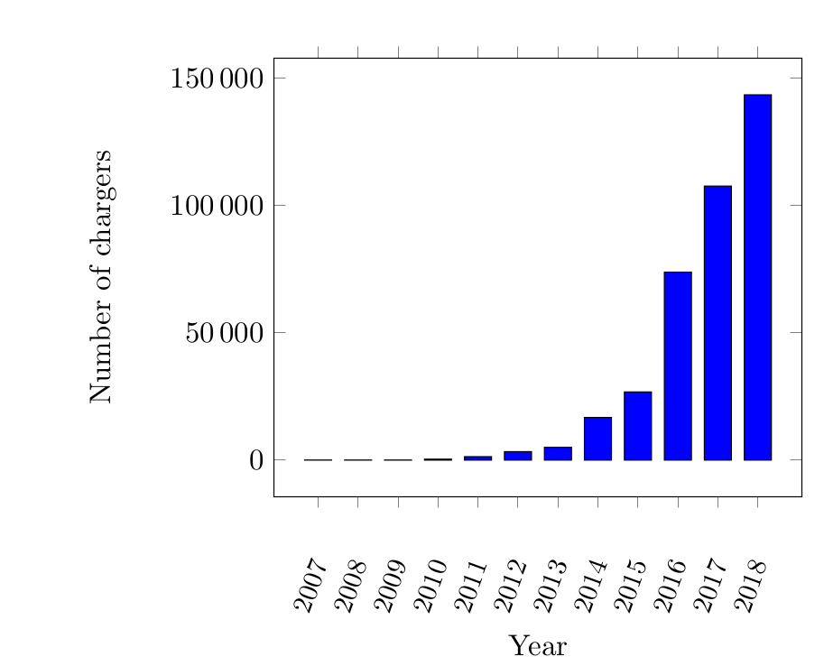Figure 1: Charging stations using OCPP

2 OCPP v2.0.1
The specification for OCPP v2.01 is publicly available, and describes the protocol with the aid of 139 JSON files, each of which specifies the format of a packet which is sent between a charger and a server. The protocol handles aspects of car charging such as pricing, transaction handling, and display and messaging support.
The specification covers many use cases that are not essential for a basic Charging Station Management System. It also includes a subset of the protocol sufficient for a basic implementation, which is the goal of this project.
3 Software Verification Tools
10 different software verification tools were considered for the development of the server, including Dafny, KeY, OpenJML, SPARK 2014, Spec#, VCC, Verifast, Viper, Whiley, and Why3. Each of these tools were investigated to determine which of the desirable criteria were satisified.

4 SPARK 2014
After considering several different verification tools, SPARK 2014 was selected for implmentation of the project. SPARK 2014 consists of both a formally defined programming language and a corresponding set of verification tools. SPARK code is compiled by the GNAT compiler, and analysed by the GNATprove tool, which uses Why3 to generate verification conditions, and Alt-Ergo, CVC4, and Z3 to prove the theorems.

5 Automatically Generated Code
As I was implementing the protocol, I noticed I was repeating many of the same steps for each packet. The packets contain JSON formatted data consisting of attribute-value pairs and arrays. The JSON specifications for each packet are included in the OCPP v2.01 protocol. I developed a JavaScript utility which parsed these JSON packet specifications, and automatically generated SPARK code to initialise, deserialize (i.e. receive text and parse into a binary format), and serialise (i.e. convert the binary format of a packet into text suitable for transmission). The script also generated postconditions for each packet.
6 References to References
A reference is made with a number in square brackets [1]. If the reference is important to the discussion—say, you intend to spend most of the paragraph discussing it—then you should use the author names as well. For instance, Shannon [5] was the first to show that a noisy channel can be used to communicate information at a non-zero rate without error. Wolniansky et al.[6] advanced the start of the art significantly when they described the V-BLAST scheme for wireless MIMO communications…
Acknowledgment
I wish to acknowledge the support of my supervisor, Associate Professor Graeme Smith, whose expertise and assistance were greatly appreciated.
References
- A. B. Smith, C. D. Jones, and E. F. Roberts, “Article title,” Journal, vol. 1, no. 1, pp. 1-10, Date.
- C. D. Jones, A.B. Smith, and E.F. Roberts, Book Title, Publisher, Location, Date.
- C. D. Jones, A. B. Smith, and E. F. Roberts, “Article title,” in Proceedings Title. IEEE, 2003, vol. II, pp. 803–806.
- Gene H. Golub and Charles F. Van Loan, Matrix Computations, Johns-Hopkins University Press, 3rd ed., 1996.
- Claude E. Shannon, “A mathematical theory of communication,” Bell Syst. Tech. J., vol. 27, pp. 379–423, 623–656, Jul./Oct. 1948.
- P. W. Wolniansky, G. J. Foschini, G. D. Golden, and R. A. Valenzuela, “V-BLAST: An architecture for realizing very high data rates over the rich-scattering wireless channel,” in Proc. URSI Internat. Sympos. Signals Syst. Electronics, pp. 295–300, Sept. 1998.
- Motorola, Inc.: DSP56002 Users Manual, 1993.
Biography
You should add a biography after all other material. The biography should focus on your professional accomplishments and interests, although can add some personal notes as well. Please keep it to less than 100 words.
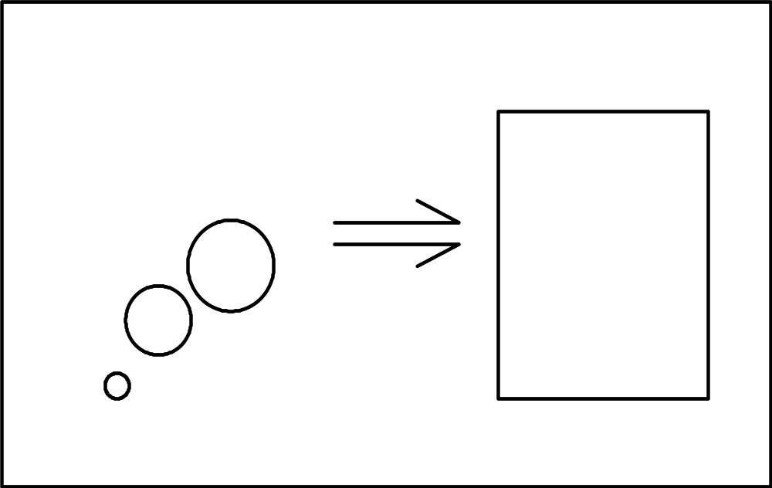Fig 2. Further and deeper thoughts (10 pt italic Times New Roman)

